PROPOSAL

OFFER
No. 2023- 888011 / MP Booth

for

Surin Automotive Pvt Ltd
Plot No.A-194 , Phase-1,
Eldeco Sidcul Industrial Park,Sitarganj U.K.

Kind Attns:- Mr. Rajesh

Project :- Sheet Metal Components

Our reference: GI:ASG:DPAP:011216
Date: 3 June 2023

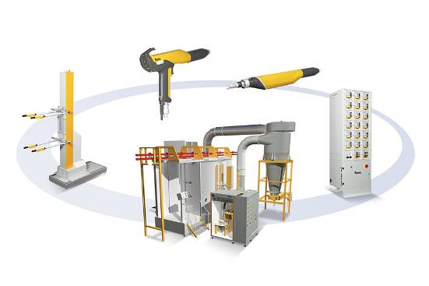

We are pleased to offer as follows:

Gema Powder Coating System, consisting of;

Item 1.00 Gema Stainless Steel Booth Type Magic Plus
with Mono Cyclone + After Filter

Item 2.00 Assembly / Commissioning

Item 3.00 Packing / Freight / Insurance

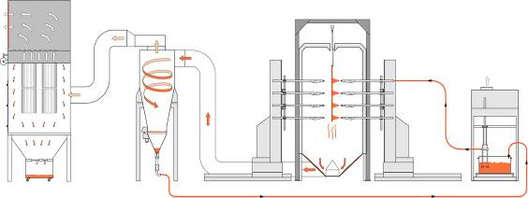

Technical Data

1.) Work piece data:
Type of Object: Sheet Metal Components
Max. Height 1200 [mm]
Max. Width 350 [mm]
Max. Length 840 [mm]

2.) Max.Coating Envelop Size

Max. Height 1400 [mm]
Max. Width 500 [mm]

3.) Production data:
Speed of Conveyor: 1.50 [m/min]

4.) Application data:
Multi Color System
Type of powder organic powders

5.) Connection values:
Compressed air data
Max. input pressure 10 [bar]
Min. input pressure 6 [bar]
Max. permissible water vapor content 1.3 [g/m³]
Max. permissible oil vapor content 0.1 [mg/m³]
Max. Compressed air consumption 80 [Nm³/h]
(Compressed air connections Required at 8 to 10 locations)

Electrical connection data:
Single phase voltage 240 [V]
Three phase voltage 3 x 415 [V+N+PE]
Frequency 50 [Hz]
Voltage tolerance ± 10 [%]
Type of protection class IP54
Max. Power consumption 30 [kW]
(Power Supply with Proper Earthing Required at 2 locations)

6.) Operating conditions:
Ambient air temperature range +10 to +40 [°C]
Work piece temperature range +10 to +50 [°C]
Air flow /Thermal current near the booth < 0.1 [m/s]
For approved coating powders only!

Item 1.00 1 Gema Color Change Stainless Steel Booth: Magic Plus
(Manufactured locally based on Gema Design & Specification)

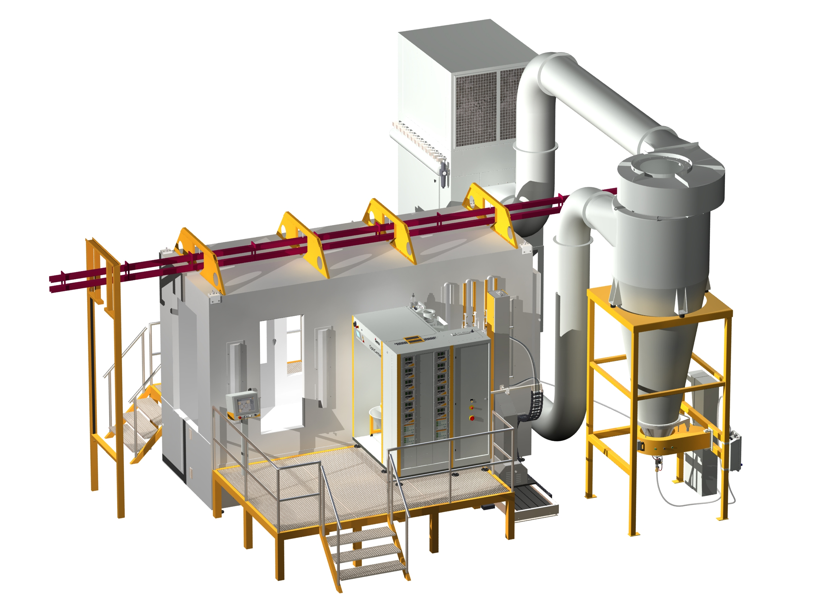

Sample of a MagicPlus system

Dimension of booth: Approximate
(without roof frame work) internal external
Length 4'700 5'000 [mm]
Width 1’500 1’900 [mm]
Height 3’400 3’800 [mm]

Booth openings
Height 1'400 [mm]
Width 500 [mm]

Item 1.01 1 Magic Plus Stainless Steel booth, quality design,

consisting of:
- Accessible base, with hinged air channel and adapter for air duct
- Upper structure, self-supporting, with two object openings, one with a pair of doors, 6 lighting in the walls, roof with frame work, holding the two walls.
- Accessible base, with hinged air channel and adapter for air duct
- Upper structure, self-supporting, with two object openings, one with a pair of swing doors, 6 lighting in the walls, roof with frame work, holding the two walls.
- 2 Gun slots per side
- Touch up Station.

Item 1.02 1 Multicolor recovery system, consisting of
Mono cyclone, exhaust air volume
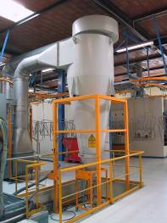

Sample Picture

Item 1.03 1 Filter, in combination with a mono cyclone,
exhaust air volume max.
consisting of:
- Filter box with fan and motor
- Filter cartridges and automatic filter cleaning system
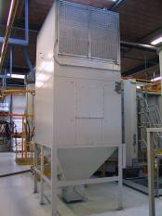
- waste powder container
- Sound level ≤ 80 [dB(A)]

Sample Picture

Item 1.04 1 Air duct between booth and mono cyclone, painted steel

Item 1.05 8 [m] Air duct between mono cyclone and after filter, made of
galvanized mild steel

Item 1.06 1 Miscellaneous

Item 2.00 1 Assembly and Start-up

Item 2.01 1 Assembly under the supervision of an Gema service engineer.

Manpower kept ready by the customer :
2 structure and steel trade man
2 fitters
1 electrical contractor
1 forklifter 3 [t], stroke 5 [m], with driver, part time.

The electrical and compressed air installations, including all necessary materials have to be supplied by the customer, according to our instructions.

Item 2.02 1 Complete start-up / commissioning, trial period, performance certificate for the plant, as well as training for your personnel under the supervision of an Gema service engineer.

Duration assembling and commissioning: approx. 2 weeks.

Conditions for assembly and start-up:

Excluded are:
- Waiting time, caused by any reason beyond Gema’s responsibility

Any other expenses not mentioned above aren’t included in our offer.

Item 3.00 1 Packing / Freight / Insurance

FOR your Works. including packing, freight and insurance.

Proposal

Commercial Offer
(INR – Indian Rupee)

Item 1.00 Gema Stainless Steel Booth Type Magic Plus
with Mono Cyclone + After Filter

Item 2.00 Assembly / Commissioning

Item 3.00 Packing / Freight / Insurance

Total Price, FOR your works INR 25,00,000/--

excluding Duties, GST & Local Taxes etc.

CONDITIONS

Par. 1 Prices
FOR your works including packing, freight and insurance.

Par. 2 Payment
50% Advance alongwith order balance 50% against PI before dispatch.

Par. 3 Delivery Time
Approximately 2 months Ex-our Works from the date of Layout approval or
which ever fall later.
If there is any delay in delivery caused by the customer, Gema will rent space
to store the units at customer’s own expense

Par. 4 Installation and commissioning
Please refer to Item No. 2.0

Par. 5 The following work and items are excluded from our delivery range:
- Building work and laying foundations on site and the
necessary drawings.
- Supply and installation of main lines and sources, electrical power
and compressed air to the equipment incl. the required switches,
valves, fuses etc.
- Switches and shut-off valves to the equipment
- Installation materials for the connections to all driven units
- All pressure release flaps and ducts to the exterior
- Suspensions for the conveyor within the area of the coating plant
- Erection aids and tools incl. necessary scaffolding
- Unloading, transport inside factory, and placing of plant items on
erection site
- Any bank or financial charges applicable within India.
- Powder for plant commissioning
- Eventually required ventilation / air conditioning of the plant.
- Any items not especially mentioned in this offer

Par. 6 Warranty
12 months from the date of Installation or 18 months from the date of Invoicing, whichever falls earlier. Warranty is applicable only against manufacturing defect. There will be no warranty if other than original Gema spare parts are used.

Par. 7 Copyright
Copying of any supplied documents, and giving them to third parties, the use or communication of the contents thereof, is forbidden without expressed authorization of Gema.
Offenders are liable to paying damages. All rights are reserved in the event of the granting a patent or the registration of a utility model or design.

Par. 8 Safety Regulations
The above mentioned equipment fulfils actual European safety rules.

Par. 9 Concluding notes
We acknowledge with thanks your above order which will be executed according to our general conditions of sales
We reserve the right to change components of the plant with your censent if thereby
no impairment of application, performance, and reliability results

Kind Regards

Value Added Coating Solution Pvt Ltd

Harish Sharma Pankaj Sharma
Director BDM

Mobile: +91 9811846214 Mobile: +91 93139086613
Email: harish@optifinish.in Email: pankaj@optifinish.in

